FPS System
# Source: AI Source: Provided by: [Data Path: Persons Table -> ID Column: 1, Name_En Column: Motasem Essam] -> From: [ChatGPT] on [7/17/2026]
The FPS System (Foot–Pound–Second System) is a non-metric measurement system that uses the foot (ft) as the unit of length, the pound (lb) as the unit of mass or force (depending on the variant), and the second (s) as the unit of time. It was widely used in the United Kingdom, the United States, and other English-speaking countries before the widespread adoption of the International System of Units (SI).
The FPS system played an important role in classical mechanics, engineering, construction, and manufacturing, and some of its units are still used today in countries that continue to use the Imperial or United States Customary System (USCS).

Definition
# Source: AI Source: Provided by: [Data Path: Persons Table -> ID Column: 1, Name_En Column: Motasem Essam] -> From: [ChatGPT] on [7/17/2026]
The FPS System is a measurement system based on three fundamental units:
- Foot (ft) for length
- Pound (lb) for mass or force (depending on the specific FPS variant)
- Second (s) for time
Its name comes from the initials of these three units:
$$\boxed{\text{FPS}=\text{Foot–Pound–Second}}$$

History
# Source: AI Source: Provided by: [Data Path: Persons Table -> ID Column: 1, Name_En Column: Motasem Essam] -> From: [ChatGPT] on [7/17/2026]
The FPS system developed from traditional English units and became widely used during the 18th and 19th centuries.
Key milestones:
- Originated from the English system of measurement.
- Used extensively in British engineering and industry.
- Adopted in early American engineering and construction.
- Gradually replaced in scientific work by the MKS and SI systems.

Characteristics
# Source: AI Source: Provided by: [Data Path: Persons Table -> ID Column: 1, Name_En Column: Motasem Essam] -> From: [ChatGPT] on [7/17/2026]
The FPS system is:
- Non-metric.
- Not decimal-based.
- Based on customary English units.
- Common in historical engineering.
- Still used in some engineering and construction fields.

Fundamental Units
# Source: AI Source: Provided by: [Data Path: Persons Table -> ID Column: 1, Name_En Column: Motasem Essam] -> From: [ChatGPT] on [7/17/2026]

Physical Quantity | FPS Unit | Symbol
Length | foot | ft
Mass or Force* | pound | lb
Time | second | s
*The pound represents mass or force depending on the specific FPS variant.

Variants of the FPS System
# Source: AI Source: Provided by: [Data Path: Persons Table -> ID Column: 1, Name_En Column: Motasem Essam] -> From: [ChatGPT] on [7/17/2026]
Historically, several versions of the FPS system have existed.
1. Absolute FPS System
Uses:
- Foot (ft)
- Pound (lbm) for mass
- Second (s)
Derived force unit:
- Poundal (pdl)

2. Gravitational FPS System
Uses:
- Foot (ft)
- Pound-force (lbf)
- Second (s)
This version became the most widely used in engineering.

Base Units
# Source: AI Source: Provided by: [Data Path: Persons Table -> ID Column: 1, Name_En Column: Motasem Essam] -> From: [ChatGPT] on [7/17/2026]
1. Foot (ft)
Measures:
- Length
- Distance
- Height
Relationships:
$$1\text{ ft}=12\text{ in} \\ 1\text{ ft}=0.3048\text{ m}$$

2. Pound (lb)
Depending on the system:
- Pound-mass (lbm)
- Pound-force (lbf)
Relationship:
$$1\text{ lb}=0.45359237\text{ kg}$$
(for pound-mass)

3. Second (s)
Measures:
- Time
The second is identical to the SI unit of time.

Derived Units
# Source: AI Source: Provided by: [Data Path: Persons Table -> ID Column: 1, Name_En Column: Motasem Essam] -> From: [ChatGPT] on [7/17/2026]
Many physical quantities are derived from the three base units.
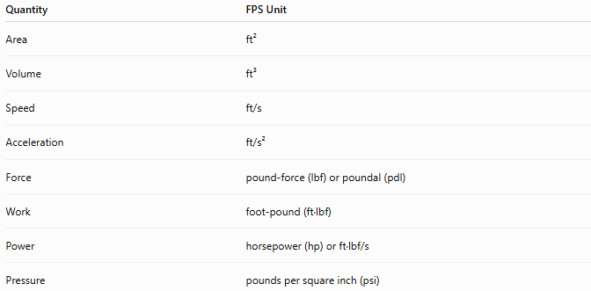
Quantity | FPS Unit
Area | ft²
Volume | ft³
Speed | ft/s
Acceleration | ft/s²
Force | pound-force (lbf) or poundal (pdl)
Work | foot-pound (ft·lbf)
Power | horsepower (hp) or ft·lbf/s
Pressure | pounds per square inch (psi)

Common Derived Units
# Source: AI Source: Provided by: [Data Path: Persons Table -> ID Column: 1, Name_En Column: Motasem Essam] -> From: [ChatGPT] on [7/17/2026]
Force
Two force units appear in FPS systems.
Pound-force (lbf)
Defined as the force exerted by gravity on a one-pound mass under standard gravity.
Relationship:
$$1\text{ lbf}≈4.44822\text{ N}$$

Poundal (pdl)
Used in the absolute FPS system.
Definition:
The force required to accelerate a one-pound mass by one foot per second squared.

Work
The common engineering unit is the foot-pound.
Definition:
$$1\text{ ft\backslash cdotplbf}$$
is the work done by a force of one pound-force acting through one foot.
Relationship:
$$1\text{ ft\backslash cdotplbf}≈1.35582\text{ J}$$

Pressure
A common unit is:
$$\boxed{\text{psi}=\text{pounds per square inch}}$$
This unit remains widely used today.

Examples
# Source: AI Source: Provided by: [Data Path: Persons Table -> ID Column: 1, Name_En Column: Motasem Essam] -> From: [ChatGPT] on [7/17/2026]
Example 1
Length
$$10\text{ ft}$$

Example 2
Mass
$$150\text{ lb}$$

Example 3
Speed
$$25\text{ ft/s}$$

Example 4
Pressure
$$35\text{ psi}$$

Advantages
# Source: AI Source: Provided by: [Data Path: Persons Table -> ID Column: 1, Name_En Column: Motasem Essam] -> From: [ChatGPT] on [7/17/2026]
The FPS system:
- Was well suited to traditional English engineering.
- Remains familiar in countries using customary units.
- Is still used in some construction and manufacturing industries.
- Continues to be used in aviation, automotive work, and tire pressure measurements.

Disadvantages
# Source: AI Source: Provided by: [Data Path: Persons Table -> ID Column: 1, Name_En Column: Motasem Essam] -> From: [ChatGPT] on [7/17/2026]
The FPS system:
- Is not decimal-based.
- Requires more complex conversions.
- Exists in multiple variants.
- Is less convenient for scientific calculations.
- Has largely been replaced by the SI system.

Applications
# Source: AI Source: Provided by: [Data Path: Persons Table -> ID Column: 1, Name_En Column: Motasem Essam] -> From: [ChatGPT] on [7/17/2026]
Historically, the FPS system was used in:
- Engineering
- Mechanics
- Construction
- Manufacturing
- Military applications
- Transportation
Today, FPS-derived units remain common in:
- Construction
- Mechanical engineering
- Aviation
- Automotive engineering
- Tire pressure (psi)
- Structural design in some countries

Everyday Examples
# Source: AI Source: Provided by: [Data Path: Persons Table -> ID Column: 1, Name_En Column: Motasem Essam] -> From: [ChatGPT] on [7/17/2026]
FPS units are still encountered when:
- Measuring a person's height in feet and inches.
- Expressing body weight in pounds.
- Measuring room dimensions in feet.
- Reading tire pressure in psi.
- Measuring elevation in feet.
- Using construction drawings in countries that follow customary units.

Common Mistakes
# Source: AI Source: Provided by: [Data Path: Persons Table -> ID Column: 1, Name_En Column: Motasem Essam] -> From: [ChatGPT] on [7/17/2026]
- Confusing pound-mass (lbm) with pound-force (lbf).
- Mixing FPS units with SI units without proper conversion.
- Assuming all FPS systems use the same force unit.
- Forgetting that the FPS system is not decimal-based.

Key Points
# Source: AI Source: Provided by: [Data Path: Persons Table -> ID Column: 1, Name_En Column: Motasem Essam] -> From: [ChatGPT] on [7/17/2026]
- FPS stands for Foot–Pound–Second.
- It is a non-metric measurement system.
- The foot is the unit of length.
- The second is the unit of time.
- The pound may represent mass or force, depending on the FPS variant.
- The system has largely been replaced by the SI system for scientific work.

FPS System vs. SI System
# Source: AI Source: Provided by: [Data Path: Persons Table -> ID Column: 1, Name_En Column: Motasem Essam] -> From: [ChatGPT] on [7/17/2026]
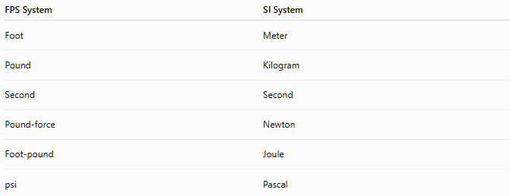
FPS System | SI System
Foot | Meter
Pound | Kilogram
Second | Second
Pound-force | Newton
Foot-pound | Joule
psi | Pascal

FPS System vs. MKS System
# Source: AI Source: Provided by: [Data Path: Persons Table -> ID Column: 1, Name_En Column: Motasem Essam] -> From: [ChatGPT] on [7/17/2026]
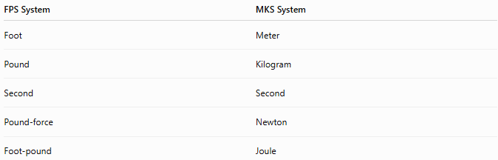
FPS System | MKS System
Foot | Meter
Pound | Kilogram
Second | Second
Pound-force | Newton
Foot-pound | Joule

FPS System vs. Imperial System
# Source: AI Source: Provided by: [Data Path: Persons Table -> ID Column: 1, Name_En Column: Motasem Essam] -> From: [ChatGPT] on [7/17/2026]
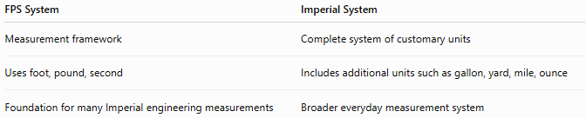
FPS System | Imperial System
Measurement framework | Complete system of customary units
Uses foot, pound, second | Includes additional units such as gallon, yard, mile, ounce
Foundation for many Imperial engineering measurements | Broader everyday measurement system

FPS System vs. United States Customary System
# Source: AI Source: Provided by: [Data Path: Persons Table -> ID Column: 1, Name_En Column: Motasem Essam] -> From: [ChatGPT] on [7/17/2026]
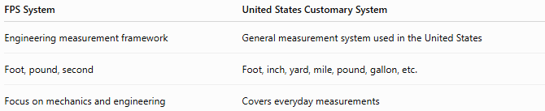
FPS System | United States Customary System
Engineering measurement framework | General measurement system used in the United States
Foot, pound, second | Foot, inch, yard, mile, pound, gallon, etc.
Focus on mechanics and engineering | Covers everyday measurements

Conclusion
# Source: AI Source: Provided by: [Data Path: Persons Table -> ID Column: 1, Name_En Column: Motasem Essam] -> From: [ChatGPT] on [7/17/2026]
The FPS (Foot–Pound–Second) System is a non-metric measurement system based on the foot, pound, and second as its fundamental units. It was widely used in engineering, mechanics, and construction before the adoption of the International System of Units (SI). Although modern science primarily relies on SI units, FPS-derived units such as the foot, pound, foot-pound, and psi remain in practical use in industries and countries that continue to employ the Imperial or United States Customary System.

